OneNote Template Instructions
November 2022

How to create a notes template in OneNote
- Create a new page in the relevant notebook in OneNote.
- Copy and paste desired text onto that page.
- If necessary, fix any formatting.
- Click the Insert tab on the top of the window.
4
5
- Click on Page Templates.
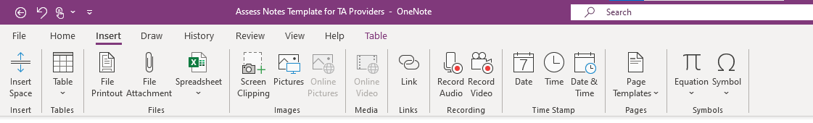
- At the bottom of the new pane, select “Save current page as a template.”
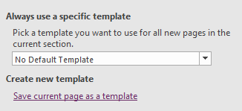
6
- Type in the name you want to use for the template and click save.

How to use a notes template in OneNote
- Open the relevant notebook in OneNote.
- Click the Insert tab.
- Click on Page Templates.
- In the new pane, select My Templates.
- Select your custom template.
- Rename the page, and start taking notes!

Copy and paste the text bellow to create the template for capturing notes for the Dynamic Impact Assess step OR use as a fillable Word document:
Initial Contact
State-Initiated and Topic Cohort questions are simply prompts, not linear, and not all are required. Develop additional questions to add if necessary.
For State Initiated TA:
Question/Prompt | Notes | Next Steps
Review state request, ask for supporting data to help TA provider better understand the context of request, and ask clarifying questions.
Discuss past or current work being done to address the issue currently. What strategies have worked, and which have not? What is driving the current request?
Request and review additional information as needed
Identify key ideas and ask clarifying questions to gain an initial understanding of the request and uncover potential underlying issues
Explain the TA process using DaSy Dynamic Impact
Identify/confirm state team members
Identify intended results of the TA
Discuss timelines
Identify next meeting date(s)
Identify any fiscal resources needed
For Topic Cohort TA:
Question/Prompt | Notes | Next Steps
Review of the State’s application and asking clarifying questions
Discuss past or current work being done to address the issue. What strategies have worked, and which have not? What is driving the current request?
Request and review additional information as needed
Identify key ideas and ask clarifying questions to gain an initial understanding of the request
Explain the Topic Cohort process using the DaSy Dynamic Impact approach and review TA agreement
Identify/confirm team members
Explain the intended outcomes of the cohort
Explain initial timelines for individual and cross-state events
Identify next meeting date(s)
Identify any fiscal resources needed

Suggested Citation
The DaSy Center (2022).. SRI International

About Us
The contents of this brief were developed under a grant from the U.S. Department of Education, #H373Z190002. However, those contents do not necessarily represent the policy of the U.S. Department of Education, and you should not assume endorsement by the Federal Government. Project Officers, Meredith Miceli and Amy Bae.
The DaSy Center is a national technical assistance center funded by the U.S. Department of Education, Office of Special Education Programs. The DaSy Center works with states to support IDEA early intervention and early childhood special education state programs in the development or enhancement of coordinated early childhood longitudinal data systems.

To learn more about the DaSy Center, visit the DaSy Center website at http://www.dasycenter.org/.

