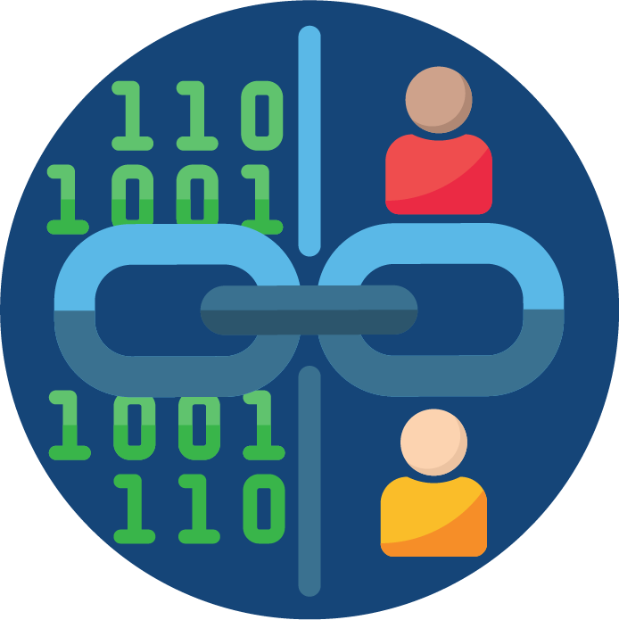
DaSy Data Linking Toolkit Step 2 Packet:

Assess Partner Readiness
May 2022
Authors:
Denise Mauzy
Bruce Bull
The contents of this document were developed under a grant from the U.S. Department of Education, #H373Z190002. However, those contents do not necessarily represent the policy of the U.S. Department of Education, and you should not assume endorsement by the Federal Government. Project Officers, Meredith Miceli and Amy Bae.

Purpose
The DaSy Center developed this packet as part of Step 2 (Assess Partner Readiness) in the DaSy Data Linking Toolkit. The packet supports initial conversations between two partners (within the same agency, or from different programs or agencies) to explore the possibility of creating a data linking partnership. It will help the partners identify points of agreement, potential barriers, and possible next steps for proceeding with the data linking partnership. Additionally, it will help the partners develop their use case, which explains the overall reason for linking the data.

How to Use the Packet
This packet includes tools that potential data linking partners can use with or without support. Involving a neutral third party is often an effective strategy in early data linking conversations.
Part C or Part B 619 program staff who are actively considering data linking are encouraged to contact DaSy (email) for assistance with preliminary considerations, development of a use case, cross-agency or cross-program facilitation, or any other aspects of data linking.
This packet includes the following tools:
- Discussion Guide About a Data Linking Partnership: This guide supports Activity 2a in the Data Linking Toolkit. It includes five broad questions and considerations about the purposes and feasibility of linking data across two programs or agencies. Given the preliminary nature of this discussion, using this guide does not convey a formal commitment to data linking. Therefore, authorized decision-makers do not need to present for this discussion. However, DaSy recommends that participants include staff with programmatic and technical knowledge. Participants may not be able to respond in detail to all questions in the guide, and some follow-up discussions may be necessary.
- Data Linking Use Case Template: This template supports Activity 2b in the Data Linking Toolkit. It is for partners who plan to continue exploring the data linking partnership. There are different types of data use case templates. DaSy designed this template specifically for data linking. Some content typically found in other data use case templates is not covered here but is included in the data linking partner management plan (Activity 3a).
To complete this template, each data linking partner may need to engage additional staff members. All participants in developing the use case should collectively understand the data to be linked, the program needs, and the expected results from the data linking.
The use case should explain the overall reason for linking the two data sets. It creates a common understanding of a specific need or currently unanswered question and establishes data linking as part of the solution. The use case formalizes the concept and demonstrates the general impact and effort of the data linking. Data linking partners can present the use case to their respective leadership and other interested parties to gain support and solidify a common vision.
DaSy developed a sample use case, Linking Part C and Part B 619 Data to Improve Services and Promote Outcomes, for data linking partners to use as a reference as they complete their own use case.

Discussion Guide About a Data Linking Partnership
Directions: Enter the meeting date and the names and titles of the participants, facilitator, and data linking partners. Jointly discuss each question and the considerations. In the comments section, record where each partner is generally on the continuum and any additional comments, including barriers. DaSy included the continuum to be a conversation starter about the level of understanding or agreement. Then, jointly reflect on the findings and determine next steps. Each partner should retain a copy of the completed document for future use.
Date:
Attendees:
Facilitator: (insert name, organization, and title)
Data Linking Partner #1: (insert name, organization, and title)
Data Linking Partner #2: (insert name, organization, and title)

Preliminary Considerations
- What level of understanding does each partner have about the purposes, potential benefits, and impacts of the data linking partnership?
Considerations:
- The purpose of the data linking for each partner.
- The benefits of linking data for each partner.
- The potential unbeneficial impacts of linking data for each partner (e.g., political impact based on the results, impact on staff directly involved with data linking).

Basic understanding In-depth understanding

Comments:

- How likely is leadership in each partner’s agency or program to be supportive of this data linking partnership?
Considerations:
- Previous support of data linking (internal, external, across programs) for each partner.
- Any guidance or restrictions leadership provided regarding previous partnerships.
- Any statutory requirements that might impede the data partnership and will need to be addressed.

Basic understanding In-depth understanding

Comments:

- What level of agreement do partners have about timing?
Considerations:
- Timeline for data linking in relation to other priorities and ongoing work.
- Date for expected completion.
- If applicable, the frequency of data linking.

(Strongly disagree) (Strongly agree)

Comments:

- What level of agreement do partners have that, between them, they can technically link the data?
Considerations:
- Methods for matching and linking data.
- Necessary technical skills and resources to support the linking activities.
- Any issues related to each partner’s data that might negatively impact the data partnership (e.g., data lag time concerns, data quality issues).

(Strongly disagree) (Strongly agree)

Comments:

- What level of agreement do partners have that, between them, they have the nontechnical resources to link the data?
Considerations:
- The legal authority to link the data.
- The expertise and availability of staff to manage and perform the data linking.
- Existing resources each partner can contribute to the data linking effort.

(Strongly disagree) (Strongly agree)

Comments:

Determine the Feasibility of Moving Forward
- Feasible: If partners agree to continue exploring the data linking partnership, they should complete the Data Linking Use Case Template below. Then, the partners can proceed with Step 3 (Formalize Data Linking Partnership) as outlined in Data Linking Toolkit.
- Not feasible: If one or both partners consider data linking not to be feasible at this time but still want to pursue the opportunity, DaSy encourages them to set a date to reconvene, undertake work to address identified barriers, meet to discuss progress on addressing the barriers, and reassess the data linking partnership.

Data Linking Use Case Template
Directions: Enter the meeting date and information about the participants, facilitator, and data linking partners. Jointly discuss and draft responses. It may take several iterations before both partners are satisfied with the result. Data partners should add the completed use case to Appendix A of their data partnership management plan developed in Step 3 in the Data Linking Toolkit.
Date:
Attendees:
Facilitator: (insert name, organization, and title)
Data Linking Partner #1: (insert name, organization, and title)
Data Linking Partner #2: (insert name, organization, and title)

Data Linking Use Case Title
(Insert title for data linking use case.)

Data Linking Use Case Overview
(Describe at a high-level, the purpose of the data linking project.)

Questions Addressed Through Data Linking
Data linking partners will be able to answer the following questions:
- (Insert questions here.)

Data Sets
(Identify all data sets needed to address the data linking use case.)

Sample Data Linking Use Case
Data Linking Use Case Title
Linking Part C and Part B 619 Data to Improve Services and Promote Outcomes

Data Linking Use Case Overview
This data linking effort will help increase the partners’ understanding of child outcomes for three groups of children: those receiving Part C services only, those receiving both Part C and Part B 619 services, and those receiving Part B 619 services only.

Questions Addressed Through Data Linking
Data linking partners will be able to answer the following DaSy Critical Questions:
- What is the relationship between service-delivery model and child outcomes?
- What is the relationship between quality of services and child outcomes?
- What is the relationship between the number of settings in which children receive IDEA services in a given time period (e.g., in a year) and child outcomes?
- What factors (e.g., amount and type of service, level, and type of personnel) contribute to better outcomes without increased cost?

Data Sets
Part C child outcomes dataset, Part B 619 child outcomes data set

DaSy modeled this Data Linking Use Case Template on the data integration use case developed by the Center for the Integration of IDEA Data.

