Excel 3-D Maps

Getting Started

Excel 2013 users – installing Power maps add-in
Follow the instructions for installing Power Map (now called 3D Maps) in Excel 2013 located on the Microsoft site (the link is below).
Use the following instructions for Excel 2016 users: https://www.microsoft.com/en-us/download/details.aspx?id=38395

Excel 2016 users
In Excel, open a workbook that has the table or Data Model data you want to explore in 3D Maps.
Note: Your table must have at least one geographic data element per row (such as state, Zip Code, city, county, countries/regions, or longitudes and latitude).
Here we’ll use a simple table of state-level data showing the “Percent of infants and toddlers receiving early intervention services under IDEA Ages Birth to One, Part C, by state: 2016.”
Click on any cell in that table:
On the Insert menu, choose 3D Maps.
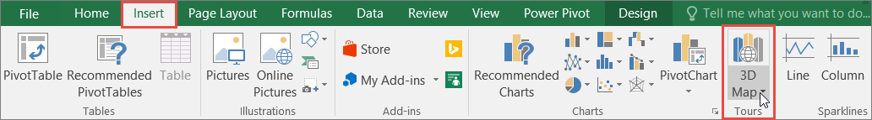
3D Maps uses Bing to geocode your data. After a few moments, the globe will appear next to the first screen of the Layer Pane.
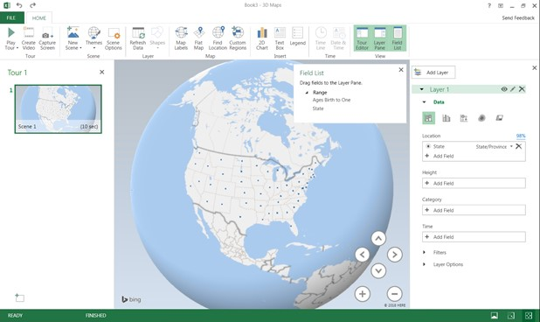
Then, in the Data area (see the image below), change the visualization to “Region,” and a new field box will appear called “Value.”
Click and drag the “Ages Birth to One” variable to the Value box as shown below.
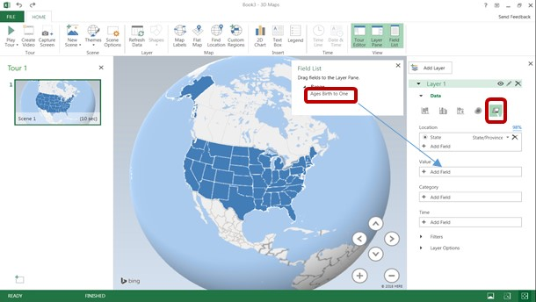
This step “binds” the “Ages Birth to One” table data to the state geolocation, adds a gradient legend to the 3D Map, and applies the gradient to all the states.
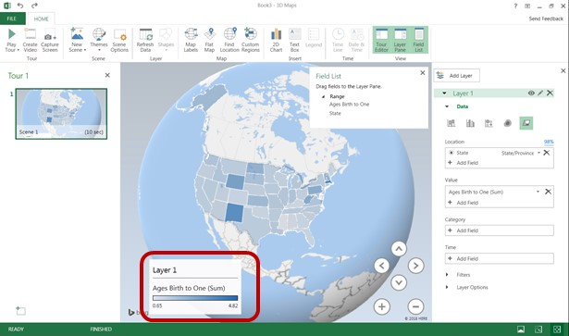
Navigate the map using the controls outlined below. The “+” and “-“ magnify and reduce the Zoom; use the direction keys to pivot the map in 3D.
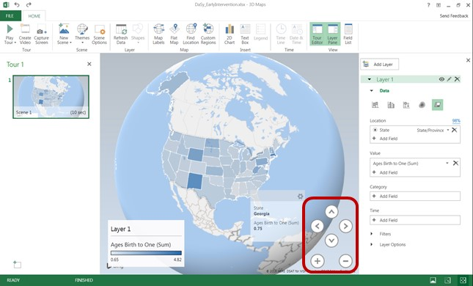
As seen above, hovering on any state will bring up the Percent of Ages Birth to One. To adjust the font for the hover box, right-click on the Legend (Layer 1 in the above image); choosing “Edit” will result in the following dialogue box:
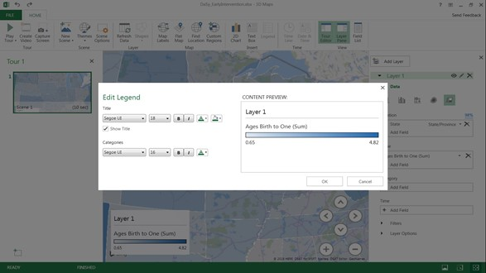
Use this box to change the font of the Legend. To change the Title from “Layer 1”, click “OK” on the Edit Legend box and click on the edit icon for Layer 1. This will allow you to edit the name in the same screen as highlighted above.
