District ___ Child Outcome Data B7
Outcome A – Positive Social-Emotional Skills (including social relationships)
Outcome B – Acquisition and use of knowledge and skills (including early language/communication and early literacy)
Outcome C – Use of Appropriate Behaviors to meet needs

SS1 – Summary Statement 1 is percent of children who entered the program below age expectations in an outcome and substantially increased their rate of growth in that outcome by the time they exited. (Improved growth trajectories during time in the program.) [(c+d)/(a+b+c+d)]
SS2 – Summary Statement 2 is percent of children who were functioning within age expectations in an outcome by the time they exited. (Functioning like same aged peers when they left the program.) [(d+e)/(a+b+c+d+e)]

Division and State Count & Percentages | 2015-2016 Division  Size:  Large | Outcome A |  | Outcome B |  | Outcome C
 |  | SS1 (A1) | SS2 (A2) | SS1 (B1) | SS2 (B2) | SS1 (C1) | SS2 (C2)
District ___ 2015-2016 |  | 92.0% | 42.0% | 93.8% | 29.6% | 90.6% | 54.3%
District ___ 2014-2015 |  | 86.4% | 41.5% | 92.3% | 32.3% | 93.6% | 55.4%
State 2015-16 |  | 91.6% | 56.6% | 94.2% | 46.2% | 91.9% | 62.5%
State 2014-15 |  | 91.1% | 58.3% | 93.6% | 50.4% | 91.2% | 64.9%
State Target 2015-16 |  | 89.8% | 57.6% | 93.7% | 46.7% | 90.7% | 65.0%
Difference (division-state) 2015-16 |  | 0.4% | -14.6% | -0.4% | -16.6% | -1.3% | -8.2%

Legend: |  |  |  | Division |  |  |  | State
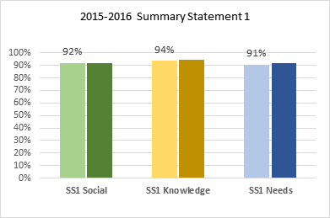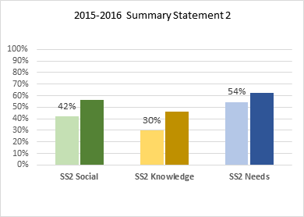
Indicator 7 Progress Categories
How do progress categories for your division compare to the state?

Small N sizes significantly affect these percentages. Divisions with less than 20 exiting children should use more caution. However, larger divisions can more confidently compare their data with the state.

Division Size
- Small = 0-19
- Medium = 20-49
- Large = 50 or more
a – Did not improve functioning
b – Improved functioning, but not sufficient to move nearer to functioning comparable to same-aged peers
c – Improved functioning to a level nearer to same-aged peers but did not reach it
d – Improved functioning to reach a level comparable to same-aged peers
e – Maintained functioning at a level comparable to same-aged peers

Progress Category | a | b | c | d | e
Division
2015-16 Outcome A | 0.0% | 7.4% | 50.6% | 34.6% | 7.4%
2014-15 Outcome A | 0.0% | 12.3% | 46.2% | 32.3% | 9.2%
2015-16 Outcome B | 0.0% | 6.2% | 64.2% | 28.4% | 1.2%
2014-15 Outcome B | 0.0% | 7.7% | 60.0% | 32.3% | 0.0%
2015-16 Outcome C | 0.0% | 7.4% | 38.3% | 33.3% | 21.0%
2014-15 Outcome C | 0.0% | 4.6% | 40.0% | 27.7% | 27.7%
State | a | b | c | d | e
2015-16 Outcome A | 0.8% | 6.3% | 36.3% | 40.6% | 16.1%
2014-15 Outcome A | 1.0% | 6.2% | 34.4% | 39.4% | 18.9%
2015-16 Outcome B | 0.5% | 5.0% | 48.3% | 41.6% | 4.6%
2014-15 Outcome B | 0.3% | 5.8% | 43.5% | 44.9% | 5.6%
2015-16 Outcome C | 0.8% | 5.6% | 31.0% | 42.0% | 20.5%
2014-15 Outcome C | 0.6% | 6.0% | 28.5% | 40.5% | 24.4%

